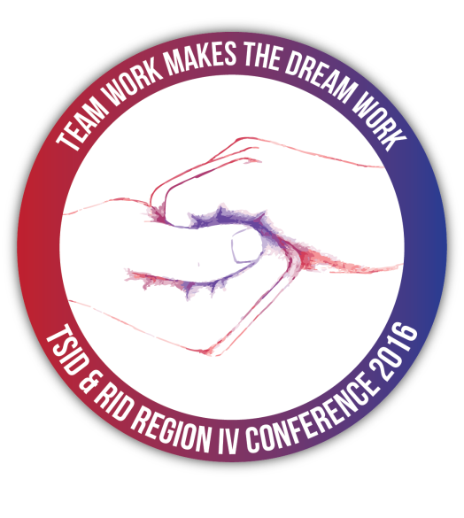
TSID & RID Region IV
Conference 2016
Call for Interpreters

Texas Society of Interpreters for the Deaf and Registry of Interpreters for the Deaf Region IV are “teaming up” once again to host the most relevant and comprehensive signed language interpreting conference of 2016. “Team Work Makes the Dream Work” will be held at the Hyatt Regency in downtown Houston, TX, July 21-24, 2016.

The Communication Access Committee is currently seeking applications from qualified interpreters to serve on the interpreting team. As a “Full-Time” Interpreter compensation package will include:

- Work 75% of conference events, which tends to average 20 hours.
- One-Half of a double occupancy hotel room for Thursday, Friday and Saturday nights (including applicable taxes, excluding incidentals)
- One Conference Combo Ticket, allowing entrance to all conference events and ability to earn CEUs, if available, for sessions not worked
- Compensation will follow the TSID policy as described below:

$35.00/hour | NIC Advanced; RID CSC, IC/TC, CI/CT, RSC, CSC, CDI; BEI III/IIIi, Advanced
$40.00/hour | NIC Master; RID MCSC, SC:L; BEI IV/IVi, V/VI, Master
$45.00/hour | RID SC:L; BEI Court and BEI Trilingual (sessions that are approved for Court or Trilingual CEUs)
*Payment for interpreted sessions will be mailed within 30 (thirty) days after the completion of the conference.
- If hired, Interpreter shall be responsible for making hotel reservations – See 2016.tsid.org for more information
- Shall be responsible for traveling to/from conference with no reimbursement.
- Shall be responsible for all meals not covered by above referenced combo registration with no reimbursement.
- Shall sign contract and return with W-9 (provided) to InterpreterCoordinator@conference.tsid.org. Shall complete time sheet (will be provided) and return to Interpreter Coordinator after the completion of the conference on Sunday for services rendered.

  - Please submit your application electronically at: https://docs.google.com/forms/d/1-BFaAS8kGjBfx8wSCjiALzexnG0FlNS_gV_QKSgdaUI/viewform
  - The URL to a sample of your work via youtube video should be inserted into the application on the submission form. All other fields in the form must be filled out in English.
  - Incomplete applications will not be considered.
*Note: TSID and RID Region IV welcome applications from CDIs and Hearing Interpreters.

Deadline for submission applications is April 29th, 2016.

Selected presentations will receive notification by May 15, 2016.

Questions? Please send an email to the Interpreter Coordinator, Stephanie Winslow, at interpretercoordinator@conference.tsid.org

